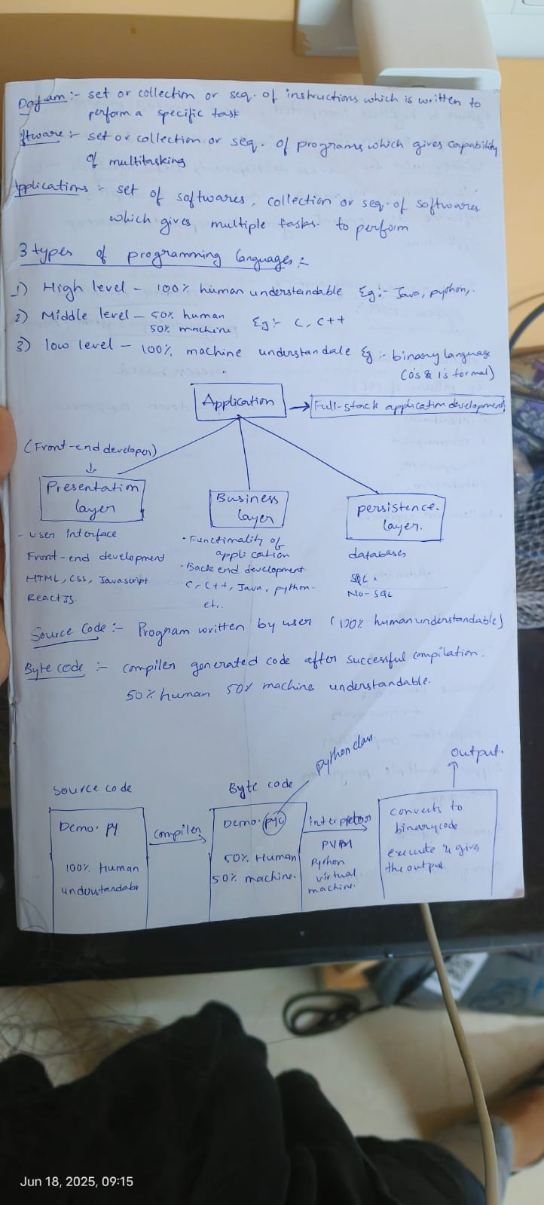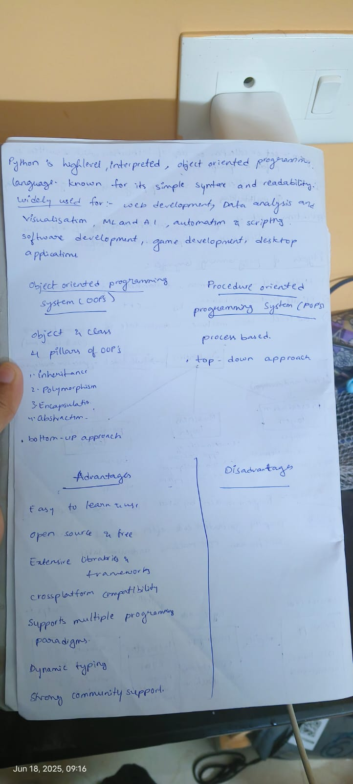

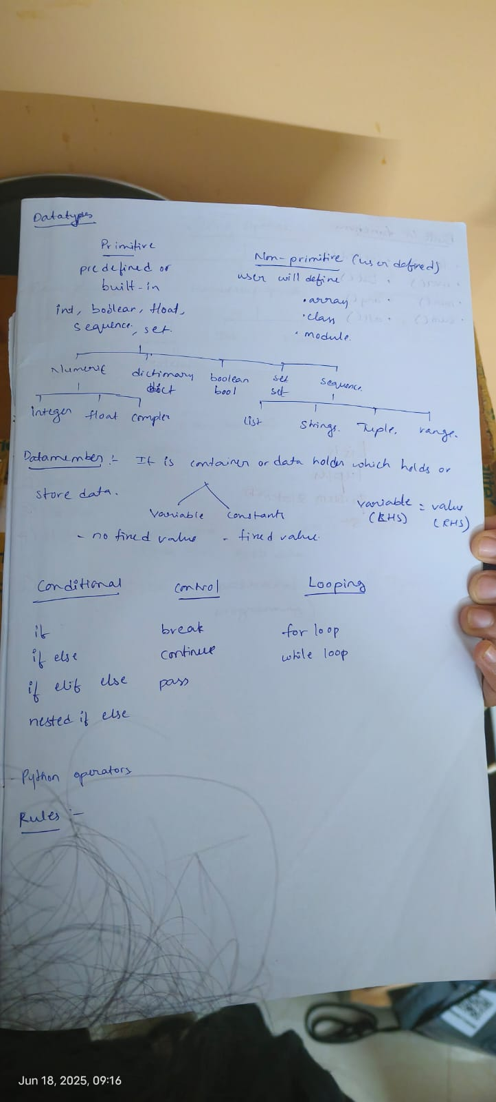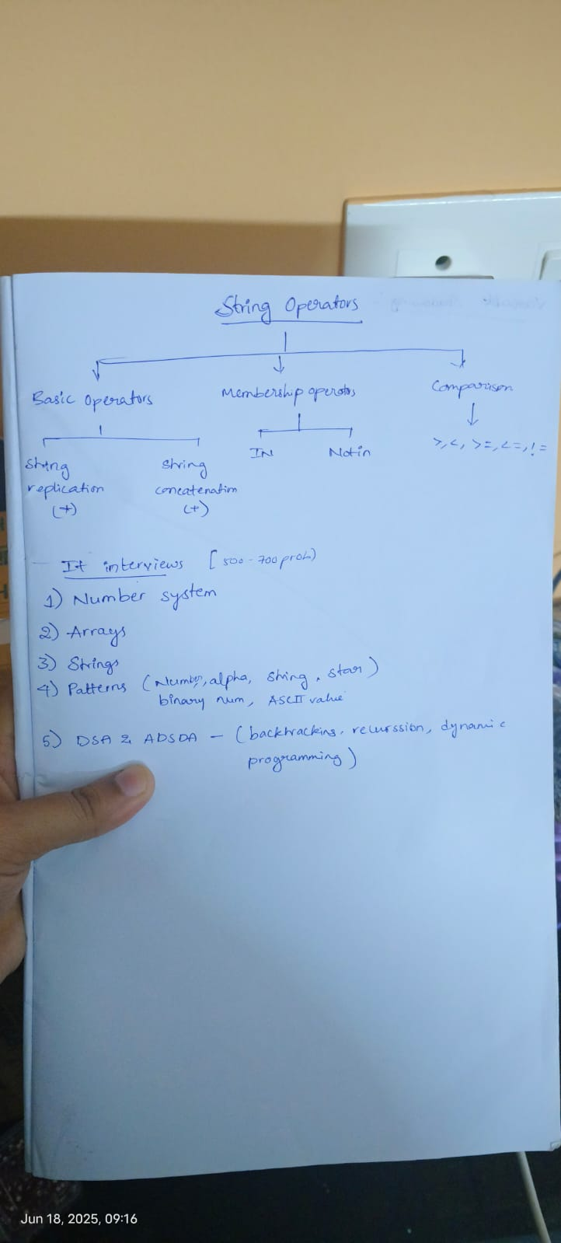

- Object Oriented Programming System- (OOP’S)
- Inheritance
- Polymorphism
- Encapsulation
- Abstraction

- ENTITY:
Anything which has the existence or anything which exists.
- Class:
Logical entity or blueprint or plan to create multiple objects
- Multiple objects created using the same class are known as IDENTICAL OBJECTS or SIMILAR OBJECTS.
- Objects:
- Real World Physical entity.
- It is also known as instance.
ClassName Rules:
- The class name can be any valid identifier
- It can’t be a Python reserved word
- A valid class name starts with a letter, followed by any number or letter, numbers, or underscores
- A class name generally starts with a Capital letter.

class Mobile: class ClassName:

Syntax:- object_name = class_name()

object_name = class_name(Arg)
- CONSTRUCTORS:-
- Python supports a special type of method called constructors for initialising the instance variable of a class.
- A class constructor, if defines is called whenever a program crates an object of that class.
- A constructor is called only once at the time of creating an instance.
- If two instances are created for a class, the constructor will be called once for each instance
Types: -
- Parameterized
- Non-Parameterized
Parameterized:
- Parameterized constructors are ones which have parameters (other than self) defined in the __init__ method’s parameter list
- This type of constructor can take arguments from the user.
Non-Parameterized:
- It is also known as the default constructor
- The __init__ method includes a single parameter self.
- No other parameters are present in __init__’s parameter list.
- Consequently, this constructor takes no arguments while creating a new object.
- Non- Parameterized constructors assign default values to the attributes of the class
The __init__() method
- This is a magic method (dunder method) which we can use to initialize variables for classes(objects).
- Every class has __init__ and this is executed when we instantiate the class.
- You can also use this method to do anything you want to do when the object is being created.
- We do not call this method explicitly
self
- self is a default variable that contains the memory address of the current object.
- This variable is used to refer all the instance variable and method.
- When we create object of a class, the object name contains the memory location of the object.
- This memory location is internally passed to self, as self knows the memory address of the object so we can access the variable and method of object
- Self is the first argument to any object method because the first argument is always the object reference
- This is automatic, whether you call it self or not.
- We can even use any other variable name instead of self-variable.

Behaviour
States
Student
Bunking classes
Gossiping
Doing Timepass
Cheating in exams
Writing exam

StudentName
StudentId
Branch
Percentage
InstituteName

OBJECT

- Behaviour of an object represents the functionality or work done by the object.
- Represented as functions/methods (technically)

- States of an object represent the properties or attributes of an object
- Represented by Data Members
(technically)

Data : raw fact that describes the attributes or properties of entity
Types Of Methods:
- Instance Methods (Object Methods)
- Accessor Methods
- Mutator Methods
- Class Methods
- Static Methods

- Accessor Method :
Used to access or read data
They do not modify the data in the variable.
Also called Getter Method
Example:
def get_values(self)
def get_result(self)
def get_name(self)
def get_id(self)
- Mutator Method :
Used to access or read data and modify the data of variables
This method can modify the data in the variable.
Also called Setter Method
Example:
def set_values(self)
def set_result(self)
def set_name(self)
def set_id(self)
Destructors: -
The __del__ method is called a destructor. It is called when an object is about to be destroyed.
It’s not commonly used, but it can be helpful for cleanup actions.
Class Dog:
Def __del__(self):
Print(f”{self.name}”)
Class Method:-
Class methods are the methods which act upon the class variables or static variable of the class.
Decorator @classmethod need to write above the class method.
By default, the first parameter of class method is class which refers to the class itself.
Static Method:-
Static methods are used when some processing is related to the class but does not need the class or its instances to perform any work.
We use static method when we want to pass some values from outside and perform some action in the method
Decorator @staticmethod need to write above the static method.

Constant
Variable
Datamembers

Global
Class(static)

instance(non-static)

Local

Global variable:-
- A variable which is declared within the class but outside of a Method, Function, Constructor. or Block is known as Global variable.
- Global variable has global scope where you can access the variable through out the program
- It has a Global Access
Local variable:-
- A variable which is declared within the class but inside of a Method, Function, Constructor. or Block is known as Local variable.
- Local variable has limited scope where you can access the variable within the given scope(either function or method or constructor)
- It has a Limited Access

Functions/Methods:
- Method Overloading
Within the same class having multiple methods with same name but different parameters is called Method Overloading
- Constructor Overloading
Within the same class having multiple constructors with same name but different signature is called Constructor Overloading
- Operator Overloading
A single operator performing different operations based on data type.
Inheritance:-
It is a process of Acquiring the properties of one class into another class.
Super Class :
The class which gives the properties to another class is known as Super class / Base class / Parent class.
Sub Class :
The class which acquires the properties from another class is known as Sub class / Derived class.
Types:
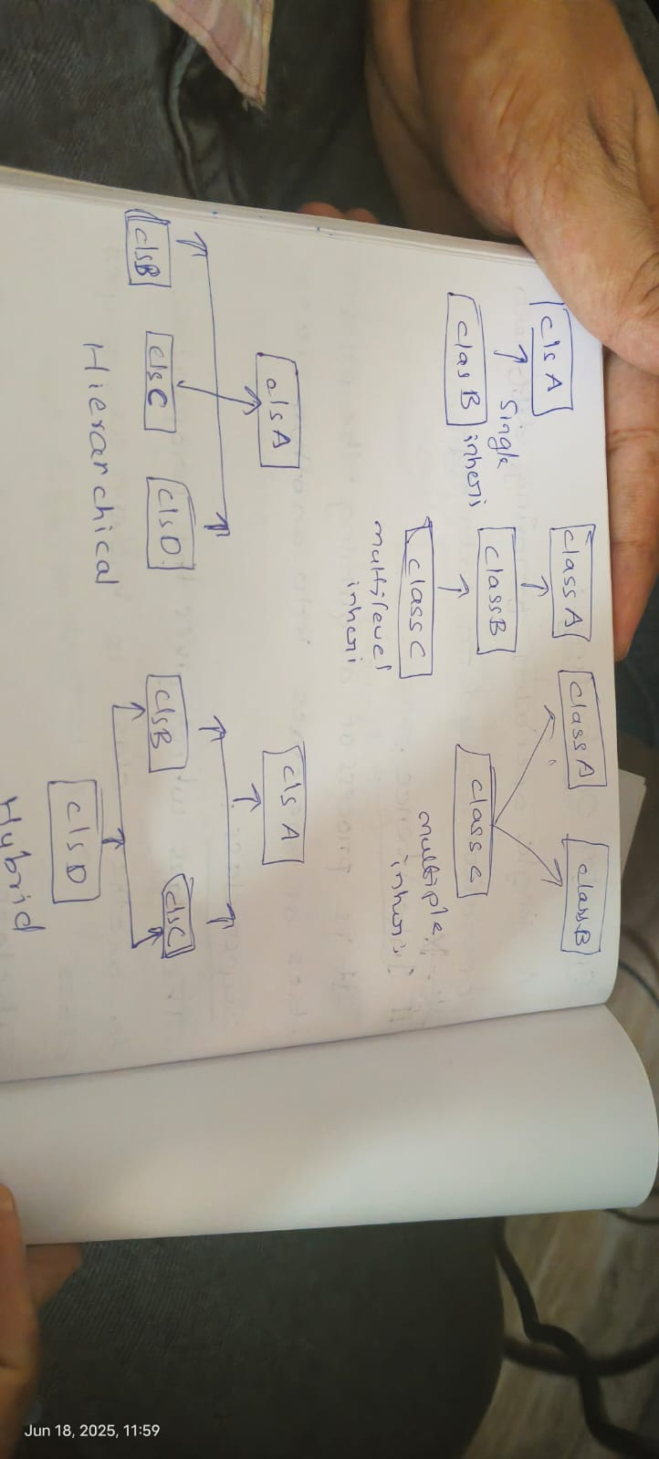

Overloading:
Within the same class having multiple methods with same name but different parameters
- Occurs in same class.
- Parameters are different
Overriding:
Providing the specific method implementation for the inherited method from super class to sub class.
- Occurs in Sub class
- Parameters are same
Polymorphism:
Poly many
Morph Forms
Performing a single task in multiple ways.
Types:-
- Compile Time Polymorphism early binding
Overloading
- Run Time Polymorphism Late Binding
Overriding
Encapsulation:
It is a process of wrapping up the states and behaviours of an entity in a single container for data security and accessing it using Data Handler methods
(Getter and setter)
Abstraction:
It is a process of hiding the implementation and providing the functionalities to the user
Interface:
It is intermediate between service and consumer

Numpy

